**Basic Block diagram**

ESP8266

Microcontroller

Display

Temperature and Humidity sensor

Battery management system

Li ion Battery

AC/DC

Converter

Fig: Block diagram of the IOT based smart weather monitoring device.

**Schematics of IOT based smart weather monitoring device**

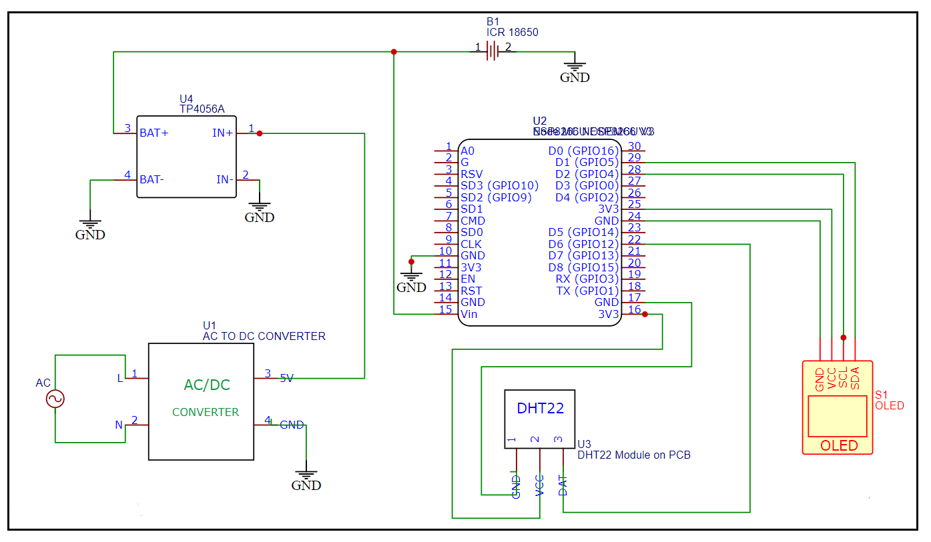

Fig : Working schematics of the weather monitoring device.